The Fayetteville office would be limited to the internet service providers that support its location. HughesNet is one of the dominant isps in North Carolina. HughesNet would make Satellite internet the main connection with fiber, cable, and T1 redundancies. HughesNet speeds are up to 100 Megabits per second (Charter Communications, 2017) (HughesNet®| Call 844-737-2700 for High-Speed Satellite Internet, 2019). HughesNet claims their connections are low-latency, which is necessary for speedy connections (Charter Communications, 2017) (HughesNet®| Call 844-737-2700 for High-Speed Satellite Internet, 2019).
Satellite Internet is known for having high-latency speeds as the connection has to travel a greater point than other internet types (Schafer, 2019). HughesNet adoption of Wi-Fi 6 allows for secure connections and better upload and download speeds (HughesNet®| Call 844-737-2700 for High-Speed Satellite Internet, 2019). These specific inclusions would impact business goals by altering the desired latency speed, as satellite internet would cause many delays in the organization's efficiency. The Fayetteville office needs speed, HughesNet promises this, but research shows that satellite connections have limitations.
The Fayetteville Office could receive up to 1 gig speed from Spectrum (Charter Communications, 2017). Wi-fi 6 is also used for better connections and lower latency. Secure Wi-Fi is offered but costs, 10 dollars a month (Charter Communications, 2017). This additional fee isn’t a negative as it allows network optimization, data protection, and simultaneous connections for 200 IOT devices (Charter Communications, 2017). The Fayetteville office would benefit from Spectrum’s use of cable connections as it would allow for fast connections. All 50 employees could use Spectrum for interruption-free video calls, thanks to the low latency speed provided by cable internet (Schafer, 2019). Fiber cables being installed means the Fayetteville office could upgrade to a faster connection if necessary.
Hardware and Software solutions for the Fayetteville office would prioritize resolving network issues. Staying up to date through a modular network system allows for easy identification of defective/broken devices. An office of 50 people requires forethought to be put into the technical requirements needed to service them. The hardware must meet the technical benchmarks for the software (Campbell, 2019). Hardware supported by software for at least the next 5 to 7 years is what the organization should look to install. A modular system would allow outdated hardware/software to be removed from the office network without causing a total failure.
The printer solution for the Fayetteville office would require a VPN for printing. The office has remote and mobile employees who use the main network through a VPN. To keep things simple, I would expand VPN usage to the printers for use through the main network. This solution allows remote and mobile employees to access the printer wherever they are through the VPN and make prints for headquarters.
Bandwidth and device fixes for video calls would include prioritizing cable and fiber. These internet connections allow for lower latency connections. This would decrease the amount of video calls dropping or freezing. The network would include a state-of-the-art router capable of upload & download speeds of 1 gigabit. Mesh topology benefits the office network by maintaining regular performance in the crisscross node setup (Keary, 2024). The network’s bandwidth would remain high for continued organizational operation.
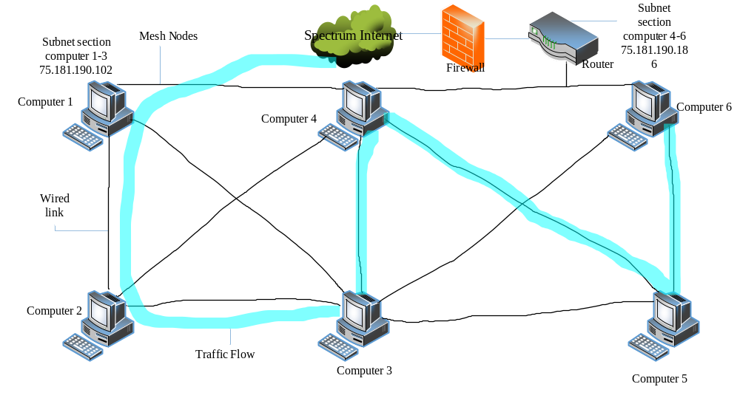

References
HughesNet®| Call 844-737-2700 for High-speed Satellite Internet. (2019). Hughesnet.com. https://www.hughesnet.com/
Charter Communications. (2017). Business Internet, Phone Services and Networking | Spectrum Business. Spectrum.com. https://www.spectrum.com/business
Schafer, D. (2019, October 15). Satellite Internet vs. Cable Internet. SatelliteInternet.com. https://www.satelliteinternet.com/resources/satellite-internet-vs-cable-internet/
Campbell, A. (2019, August 6). 5 Considerations When Choosing Hardware for your Business. 5 Considerations When Choosing Hardware for Your Business. https://www.sba.gov/blog/5-considerations-when-choosing-hardware-your-business
Keary, T. (2024, January 10). Network Topology: 6 Network Topologies Explained [Including Diagrams]. Comparitech. https://www.comparitech.com/net-admin/network-topologies-advantages-disadvantages/

